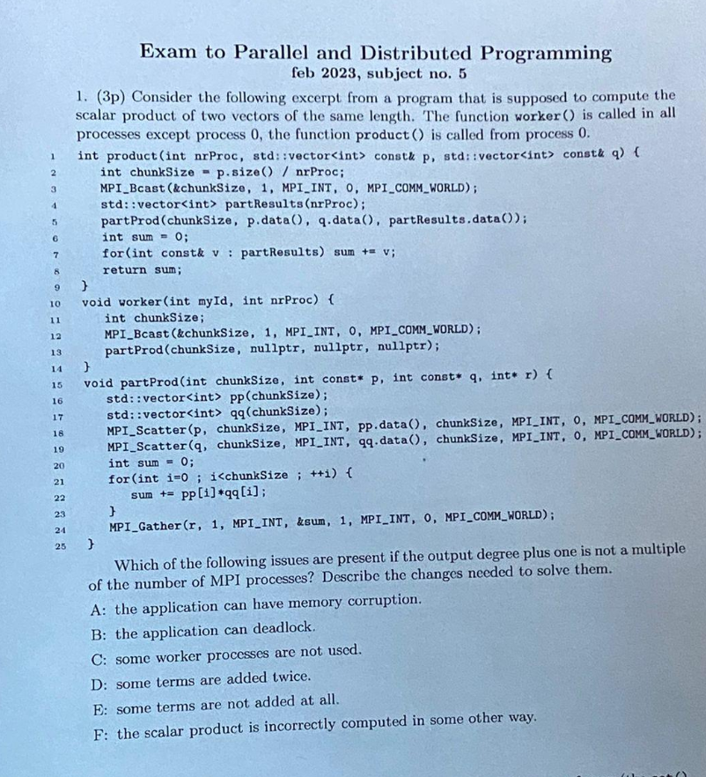
A,E
A: MPI_Gather form is wrong, send sum, not r, because r is nullptr if called from child
E: vector<int> sendcounts(nrProc);
vector<int> displs(nrProc);
int total_elements = p.size();
int remainder = total_elements % nrProc;
int sum = 0;
for (int i = 0; i < nrProc; i++) {
// Distribute remainder: first 'remainder' processes get +1 element sendcounts[i] = total_elements / nrProc + (i < remainder ? 1 : 0);
displs[i] = sum;
sum += sendcounts[i];
}
// 2. Use MPI_Scatterv instead of MPI_Scatter
// Note: We need to do this for both vector p and vector q MPI_Scatterv(p.data(), sendcounts.data(), displs.data(), MPI_INT, pp.data(), sendcounts[rank], MPI_INT, 0, MPI_COMM_WORLD);
MPI_Scatterv(q.data(), sendcounts.data(), displs.data(), MPI_INT, qq.data(), sendcounts[rank], MPI_INT, 0, MPI_COMM_WORLD);

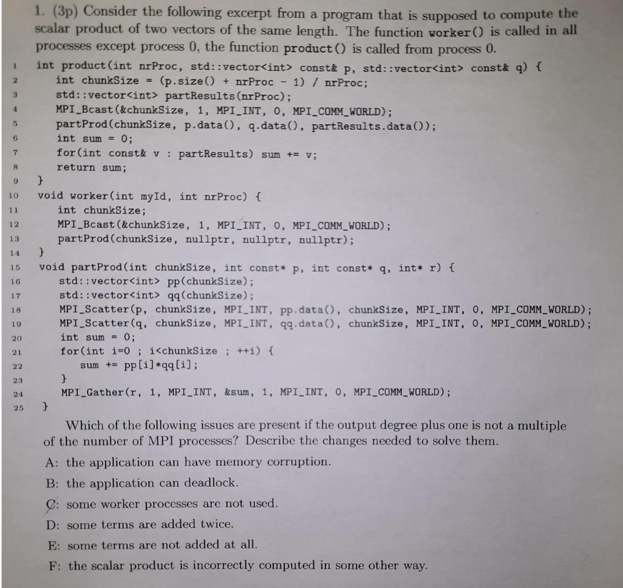
A:Use MPI_Scatterv instead of MPI_Scatter. Calculate sendcounts array (distributing the remainder size % nrProc) and displs array to send the exact number of elements to each process without reading out of bounds.Correct the MPI_Gather call: swap the buffers. Pass &sum as the send buffer (local data) and r (which points to the partResults vector) as the receive buffer. MPI_Gather(&sum, 1, MPI_INT, r, 1, MPI_INT, 0, MPI_COMM_WORLD);"

